
Swimming Pools and Hot Tubs

This handout is intended only as a guide and is based in part on the 2020 Minnesota State Building Code, Isanti City ordinances, and good building practice. While every attempt has been made to ensure the correctness of this handout, no guarantees are made to its accuracy or completeness. Responsibility for compliance with applicable codes and ordinances falls on the owner or contractor. For specific questions regarding ordinance & code requirements, refer to the applicable city ordinances, codes, or contact the Isanti Community Development Department.

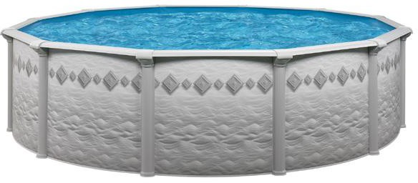
Permits
1.) A Zoning Permit is required for any structure intended for swimming, recreational bathing, or wading that contains water over 24” deep. This includes in-ground, above ground, or on-ground pools; hot tubs; spas; and fixed in place wading pools.
2.) A Building Permit is required for any structure over 24” deep and
over 4,999 gallons containing water intended for swimming, recreational bathing, or wading. A hot tub installed on a deck requiring alterations or additions for the added weight may also require a building permit. (NOTE: PLEASE TAKE THE ADDITIONAL WEIGHT OF A FULL HOT TUB INTO CONSIDERATION!! Your
deck was likely not designed to support the weight of a full hot tub.)

- Permits should include the following:
  - Site plan showing existing structures, locations, and property lines. Include the proposed location and measurements of pool, size, depth, and setbacks from property lines.
  - A copy of the manufacturer’s instructions for installation (if available)

3.) An Electrical permit may be required for hot tubs, and swimming pool pumps / heaters.

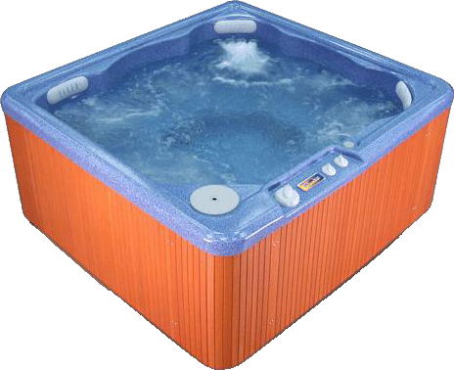
Required Inspections
1-2 inspections will be required to call 24 hours in advance to schedule inspections.

Requirements
All pools and hot tubs must meet the following City ordinance requirements.
- Barriers.
Option 1) Storable pools [24”+ wall height] the ladder shall be removed and the pool covered when not in use.
Option 2) Permanent (rigid frame) above ground pools with wall heights of 24”-47” pools always require a 48” high barrier. With wall height of 48” or more, shall secure or remove all accesses and/or ladders when not in use.
Option 3) Hot tubs & spas shall have a compliant lockable cover.
Option 4) All other pools, and hot tubs without locking covers shall have a min. 48” high barrier and/or fence that completely surrounds and restricts access to the pool.
Please contact the Community Development Department for specific barrier/gate requirements.
- Pools shall be located in the rear yard only, and shall not be located in any easements.
- Pools shall be set back a min. of 5’ from any side or rear lot line.
- There is a maximum allowable amount of impervious surface area that can be covered on a property, including all accessory buildings, drives, patios, etc. Coverage must be verified before any construction or installation begins.

110 – 1st Avenue NW * Isanti, MN 55040
Phone: 763-762-5753 permits@cityofisanti.us
5.4.2026

